# Coffee Shop Website Report

For this assignment I am making a Coffee Shop website with 5 individual pages named

Home page, About Us Products, Events, Contact Us. The aim of my website is to create a working website using HTML.

## A collage of different types of coffeeOverview of the website from the user’s perspective.

Figure 1, my Homepage. The user experience on this webpage is good as it has a working navigation and a clear navigation bar. The information is clear for the user to read, and the colour scheme is good. And the pictured are nice and clear for the user to see.

Figure 2, this is the About Us page, the navigation bar are working and clear, the information about the coffee shop is in clear black font at a reasonable and readable size and the colour scheme is okay, it would be better if the page had more colour to attract users.

Figure 3, this page is the products page, the navigation bar is clear on the top right corner, the information presented on this page is clear and readable and aligned to make sure people can read it without struggling the colour scheme is okay, could be better to attract users, the pictures are clear. 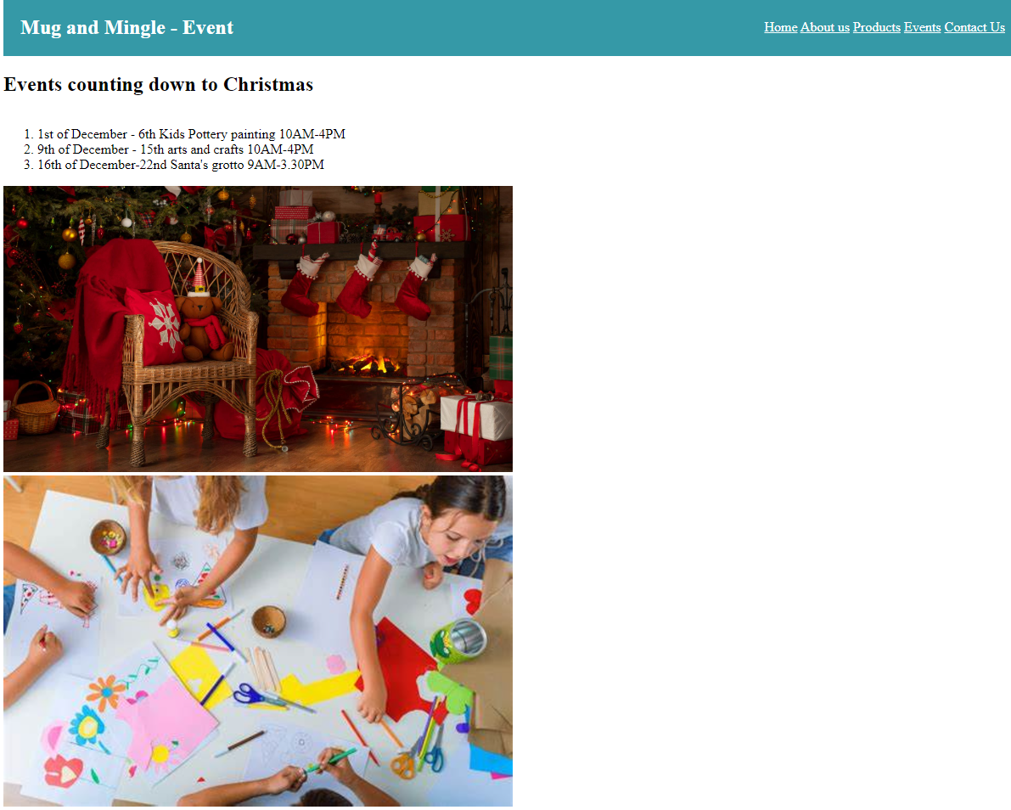

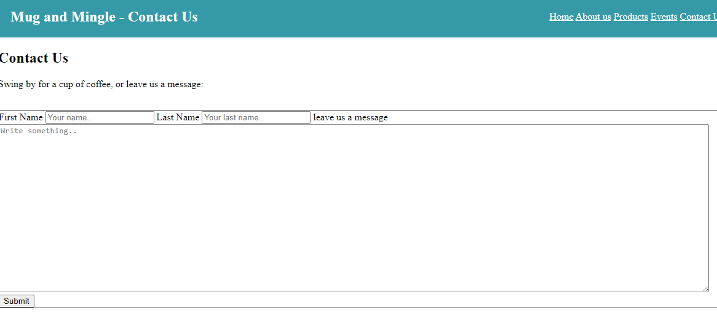Figure 4, this page is the Events page, this page consists of the activities that are going on in weeks leading up to Christmas and they are put in a numbered list to help the user, the colour scheme is okay, but I want to make it more colourful.

Figure 5, contact page this page is straight forward to the user, the navigation bar is at the top right corner and the navigation works to get the user to other pages effectively and easily, the form is easy as you can put your information down and it will send to the owners of the shop, the colour scheme is okay but I would like to change to make it more vibrant.

# how I made my site Accessible

the first thing I did was add a title onto the page to tell the user which page is which, using a h1 tag to make it a header.

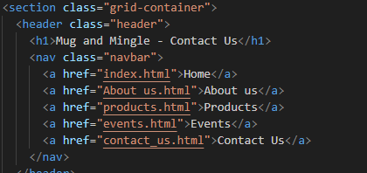The second thing I added was a navigation bar to let the user get around my website easily and effectively as some people find it hard to navigate websites.

For my Products page I have used the <li> to create a numbered list to show the products I have but the customers can easily see, I also use <span> to make my list look neat and to show the prices easily.

## Discussion of my HTML

For my website I used semantic tags as they clearly define what the code is meant for, for my website I have used the semantic tags h1 which is a header that is placed on the top left of my website, I have used this to make sure that the users of my website can clearly see what page they are on.

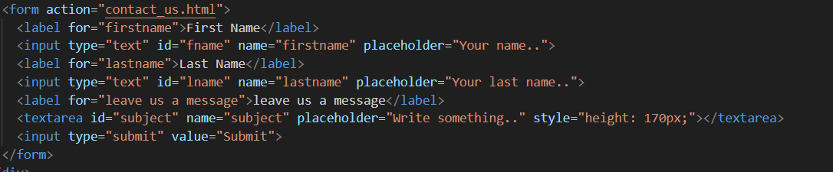I have also used the semantic tags <form> this is to create a form that you can input your firstname and lastname and then can send a message to the company. The form is straight forward.

I used the <article> for the the products page, I used the article tag as it is used for self conatined content that will not be included in the other parts of my website. I alos used the <span> tag to make sure the prices of my products are all alingned to make the page look neater and its easily read for the customer

### The benefits of using semantic tags

The benefits of using semantic tags are that it improves accessibility in two ways, the first benefit is that semantic tags are better for mobile applications because it requires less memory that a non-semantic tag, the second way is semantic HTML improves the responsiveness because the web browser can interpret the code better. Another benefit to use semantic tags that the code will run seamlessly and smoothly, and it benefits screen readers as the semantic tags are clearly defined in the code.

### A screen shot of a computer program Description automatically generatedDiscussion of my CSS

Figure 1. My CSS has styled my webpage to how I would like to be.

This is my style.css page where this is linked to all my webpages, this page has the contents of of my header colour, the font colour and size

My CSS has styled my webpage to how I would like to be.

This is my style.css page where this is linked to all my webpages, this page has the contents of of my header colour, the font colour and size.

Figure 2. This is my Index page CSS. The. centre is for the text align this makes the text looks neat and the main li is for a certain part of information that I wanted to show my audience. The reason I have used these tags in CSS is mainly for the text and making the page look neat and tidy.

Figure 3. This is the about us page and this is my CSS, and, on this page, it is just a paragraph, so for this page I have made sure the font size and font weight is good as the customers can easily read the information that is on the page.

products

Events

Contact us

